SMART FLOOR CLEANING SYSTEM

1st Shivakumar k v   
Electronics and communication engineering  
Alva's institute of engineering and technologyMangalore, India  
[4al21ec079shiva@gmail.com](mailto:4al21ec079shiva@gmail.com)

2nd Shashank Swamy

Electronics and communication engineering

Alva's institute of engineering and technology

Mangalore, India

[4al21ec077@gmail.com](mailto:4al21ec077@gmail.com)

3rd Prasanna Kumar B.I

Electronics and communication engineering

Alva's institute of engineering and technology

Mangalore, India

[4al21ec064@gmail.com](mailto:4al21ec064@gmail.com)

4th Shashank Viresh Sheeti

Electronics and communication

engineering

Alva's institute of engineering and

technology

[4al21ec078@gmail.com](mailto:4al21ec078@gmail.com)

5th prof. Sudhakara H M

Electronics and communication

engineering

Alva's institute of engineering and

technology

[sudhi123@aiet.org.in](mailto:sudhi123@aiet.org.in)

***Abstract***

The smart floor cleaning system is an innovative technology that automates and improves the efficiency of floor cleaning processes. This system uses advanced technology including robotics, sensors, and artificial intelligence to perform self-cleaning tasks. The device has a variety of sensors that allow it to detect obstacles, navigate complex settings, and distinguish different types of dirt and waste. It uses clever algorithms to optimize cleaning patterns and adapt to various floor surfaces. The system also includes features like remote control, scheduling, and real-time monitoring via mobile applications. This smart cleaning solution reduces human labor, enhances cleaning consistency, and boosts overall hygiene standards in both home and commercial settings. Integrating IoT (Internet of Things) technology enables data collecting and analysis. enabling ongoing improvement in cleaning performance and energy efficiency. This abstract introduces the smart floor cleaning system, including its major components and possible benefits in modern cleaning operations.

***Keywords***—*Arduino Uno, Servo motor, Moter driver L298N, Water Pump, DC Motors, Bluetooth Sensor HC-O5*

# **Introduction**

Cleaning is a necessary duty, but many people disregard it because of their hectic schedules. Using traditional cleaning procedures can be time-consuming and exhausting. However, cleanliness is critical for physical health, emotional well-being, and productivity. To solve this, novel cleaning methods, particularly floor scrubbers, have been created. Previous models had drawbacks like as inefficiency and intricate wiring, making them difficult to use.

Now, the smart floor cleaning system provides a significant leap by operating autonomously, removing the need for human cleaning. This equipment saves time, effort, and energy by completing dry cleaning operations simultaneously. Many individuals struggle to clean their houses every day, but this approach allows them to maintain cleanliness easily. A clean atmosphere lowers dust and germs, resulting in a healthier and more pleasant space while lowering stress. Furthermore, businesses benefit from this method since it gives a low-cost alternative to keep offices clean without hiring additional employees. Traditional cleaning methods are time-consuming, but smart technology streamlines the process, making it faster and more efficient.

As technology advances, technologies such as the smart floor cleaning system enhance hygiene and ease, allowing people to focus on work, family, and personal interests without worrying about everyday chores. technology is transforming how people clean their homes and workplaces. The smart floor cleaning system is an excellent illustration of this. It makes cleaning easier, faster, and more effective. It conserves time, energy, and effort. It also promotes good hygiene and overall well-being.

The future, more advanced cleaning technologies could be created. These advancements will continue to make life simpler. The idea is to lessen the amount of housekeeping. This allows people to relax and enjoy their time without having to tidy. The smart floor cleaning technology is a step toward a more convenient and efficient future. This technique frees people from the pressure of domestic tasks by expediting the cleaning process, allowing them to focus on other important things like jobs, family time, or personal interests

# **Ease of Use**

The smart floor cleaning system's ease of use, combined with components such as Arduino Uno, Servo Motor, Motor Driver L298N, Water Pump, DC Motors, and Bluetooth Sensor HC-05, results in an efficient and user-friendly cleaning solution. The Arduino Uno acts as the primary controller, handling all of the components and guaranteeing proper operation. The use of DC motors allows the device to move autonomously, reducing the requirement for manual effort. The Motor Driver L298N efficiently regulates the motors' movement, allowing the system to easily navigate diverse floor surfaces. The servo motor increases precision by changing the cleaning mechanism as needed. The use of a water pump allows effective wet cleaning by delivering water or cleaning chemicals at the proper time.

proper time, which improves the overall cleaning process.

The Bluetooth Sensor HC-05 supports wireless communication, allowing users to remotely operate and monitor the device using a smartphone or other Bluetooth-enabled devices. This feature improves convenience by allowing users to operate the system without requiring direct physical engagement. The smart floor cleaning system's design requires little maintenance while providing optimum effectiveness, making it an affordable and practical solution for both homes and businesses.

Its autonomous function enables users to concentrate on other things without worrying about floor cleaning. Furthermore, the system's tiny form allows it to easily travel and clean even difficult-to-access regions. The combination of these components creates a highly efficient cleaning gadget that simplifies residential and commercial cleaning operations.

The use of Arduino Uno ensures straightforward programming, allowing for tweaks or upgrades as needed, making the system adaptable to a variety of cleaning requirements. The Bluetooth control function reduces the complexity of wired connections, resulting in a more smooth user experience. The smart floor cleaning system is a perfect alternative for modern cleaning solutions since it integrates all these components, saving manual work while keeping cleanliness effective. This breakthrough showcases automated cleaning systems developments, improving hygiene while saving time and energy.

The system's user-friendly design assures that those with little technical understanding can easily run it. As technology advances, additional enhancements can be made to increase its functionality, making cleaning even more efficient and accessible.

It also lowers the need for human work, making it a cost-effective choice for individuals and enterprises. Unlike traditional floor-cleaning methods, which require substantial effort and time, this automated system streamlines the process, allowing users to focus on work, family, or leisure activities without having to worry about regular cleaning responsibilities.

The use of modern technology improves cleaning precision and efficiency, avoiding missed spots and uneven cleaning. Furthermore, the system's tiny and lightweight design allows it to easily traverse through narrow places, reach corners, and fit under furniture. The addition of Bluetooth connectivity improves accessibility, making it a great choice for smart homes. This intelligent floor-cleaning technology not only enhances cleanliness but also promotes a healthier living environment by reducing

Allergens and microorganisms. As technology progresses, such automated solutions become increasingly important in modern families, offering simplicity of use, efficiency, and comfort in daily life. With its user-friendly design and great performance, the smart floor cleaning system is a dependable and practical tool for easily maintaining cleanliness.

1. **METHODOLOGY**

The smart floor cleaning system is intended to automate the cleaning process by utilizing modern components, ensuring efficiency and convenience of use. This system's methodology is based on the use of an Arduino Uno microcontroller as the central processing unit, coordinating multiple sensors, motors, and cleaning mechanisms. The system is powered by a rechargeable battery and includes numerous ultrasonic sensors, an infrared sensor, a motor driver, and a Bluetooth Low Energy (BLE) module. The ultrasonic sensors are strategically placed to detect impediments in the cleaning route, reducing collisions and allowing for smooth navigation. The IR sensor improves the detecting capabilities by identifying dirt and surface irregularities, allowing the system to adjust cleaning intensity appropriately.The BLE module enables wireless connectivity, allowing users to manage and monitor the cleaning system from their smartphones or distant devices. The motor driver regulates the functioning of several motors (M1, M2, M3, and M4) that control the cleaning system's

Fig1: Proposed system’s overview

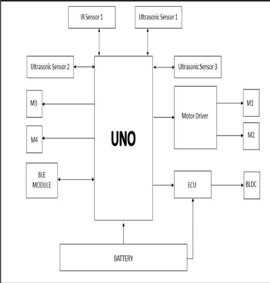movement, ensuring smooth mobility across various surfaces. Furthermore, a Brushless DC (BLDC) motor is included for efficient suction and scrubbing action, which improves cleaning performance. The Electronic Control Unit (ECU) controls power delivery to various components, ensuring efficient energy use and system longevity.

The rechargeable battery provides a long-lasting power supply, allowing the device to run autonomously. When turned on, the cleaning system moves across the targeted area, using its sensors to avoid impediments and navigate effectively. The combination of motorized brushes and suction mechanisms effectively removes dust, dirt, and stains from the floor surface. The device can clean both dry and wet surfaces, making it suitable for a variety of contexts including homes, offices, and commercial areas. Users can personalize cleaning schedules and settings via the mobile app, making the device very flexible to individual needs. The use of smart navigation technology enables the system to map the cleaning area and optimize its route, reducing redundancy and increasing productivity. This automation lowers the need for manual intervention, making cleaning more convenient and time-efficient. The smart floor cleaning system is especially useful for individuals with hectic schedules, senior users, and organizations searching for cost-effective maintenance solutions.

Compared to traditional cleaning methods, this automated solution requires less human labor while increasing cleaning efficiency. Its tiny size lets it reach tight places and corners that are typically difficult to clean by hand. The usage of real-time monitoring via Bluetooth connectivity allows customers to track cleaning progress and battery status remotely. This technological development not only enhances cleaning but also contributes to a better living environment by lowering allergens and bacteria. As technology advances, smart cleaning devices like these will play an important part in upgrading domestic and commercial cleaning solutions. With its user-friendly interface, efficient operation, and automatic functionality, the smart floor cleaning system is a big step toward smarter and more convenient cleaning procedures.

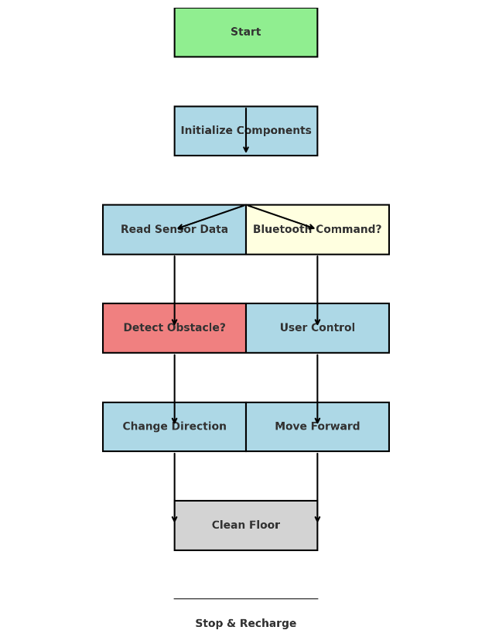

Fig: Initial Flow chart of the proposed system

The Smart Floor Cleaning System flowchart depicts the system's step-by-step operation, which includes numerous sensors, motors, and communication components for autonomous cleaning. The process begins with the Start phase, in which the system is powered on and ready for use. The first important stage is Initializing Components, in which the Arduino Uno activates and configures all necessary modules, such as ultrasonic sensors, an IR sensor, a motor driver, the Bluetooth module, and power distribution via the battery. After initialization, the system starts the Sensor Data and Bluetooth Command Processing phase. The ultrasonic and infrared sensors collect environmental data to detect impediments and evaluate floor conditions, while the Bluetooth module listens for prospective user orders. If a Bluetooth Command is received, the system grants User Control, allowing manual navigation via a smartphone or remote device. However, when operating independently, the system checks for impediments using the Detect Obstacle. decision point. If an impediment is spotted, the system calls the Change Direction function, which adjusts the path to prevent collisions. If no obstacles are discovered, the system proceeds to Move Forward and continues its cleaning procedure. Regardless of the navigation technique, the system assures effective cleaning during the Clean Floor phase, which involves motorized brushes and suction mechanisms working together to remove dirt, dust, and debris. The device can vary between dry and wet cleaning modes based on the user's choices or the floor conditions. This process is continued indefinitely until the system requires recharging. The automated obstruction detection technology ensures safety by avoiding damage to furniture and unwanted stops. Overall, this methodology improves automation in residential and industrial cleaning, paving the path for more intelligent, self-sufficient cleaning systems. As technology improves, improvements in AI and machine learning may further optimize this system, allowing for real-time learning for better navigation and cleaning precision. The Smart Floor Cleaning System is a significant advancement in cleaning technology, providing the ideal combination of automation, efficiency, and human control to ensure a hassle-free and successful cleaning experience.

1. **LITERATURE SURVEY**

The author explores how modern science continues to improve in ways that make daily life simpler. One such innovation is the Smart Floor Cleaning Robot, which is intended to automate floor cleaning efficiently. The author highlights the significance of cleaning and hygiene, pointing out that busy lifestyles frequently leave people with little time for housework. This robot addresses that issue by providing remote control capabilities via a built-in Wi-Fi module [1].

The robot comes equipped with a tiny vacuum cleaner for dust collection and a motorized mop that cleans the floor with water. The author emphasizes the ease of emptying the vacuum after cleaning. Future advancements, such as mapping technology, may increase the robot's capacity to clean every area of

space effectively. The author's goal with this project is to create a basic yet effective robotic solution for automatic floor cleaning [1].

The author outlines the creation of a smart cleaning robot designed to ease and automate household cleaning activities. The major purpose of this robot is to reduce human involvement in the cleaning process. The proposed system includes both mopping and vacuuming functions. The mopping component comprises a mop that is attached to a tiny water container, allowing it to stay wet for excellent floor cleaning. Meanwhile, the vacuum portion has a vacuum pump that captures dust particles. An Arduino Mega microcontroller manages the entire system, including hardware and software activities [2].

A GSM module is used to allow the robot and the user to communicate wirelessly. Upon activation and when the mop needs to be replaced, the robot gives the user an acknowledgment message. Users can choose between dry and wet cleaning modes depending on their preferences. In addition to the remote control, the robot can be turned on and off manually using external buttons. The robot is designed to sweep and mop, and it has obstacle avoidance and collision-free navigation skills, ensuring effective cleaning when the user commands it [2].

The author covers the uses and benefits of smart floor-cleaning robots in a variety of settings, including homes, airports and train platforms, hospitals, bus stops, malls, and other commercial places. Traditional cleaning methods based on brooms and mops have been replaced with robotic alternatives, which improve efficiency and reduce manual labor. The robot is implemented using an Arduino controller, which supervises its activities [3].

The robot can execute a variety of cleaning duties, such as sweeping, mopping, dust collection, and sanitization. It functions independently, ensuring that floors remain clean without the need for human interaction. Once engaged, the robot can clean and maintain hygiene throughout the house, eliminating the need for manual labor. The designed equipment is autonomous, making it a practical and efficient answer for today's cleaning demands [3].

The author addresses the rapid progress of science and technology, which are always evolving to improve human comfort. The primary goal of this study is to create an automatic Smart Floor Cleaner that can be controlled from an Android device. This robot is intended to efficiently remove dust and grime from various surfaces, including floors, upholstery, and draperies [4].

The system incorporates a controller that powers the motors and suction unit, as well as sensors that identify and avoid obstructions. This idea intends to improve people's quality of life by lowering the amount of effort required to clean. Researchers are increasingly interested in robots as they try to make everyday living more convenient and efficient, thanks to constant technological improvements [4].

The author Analyzes the impact of robotics on human life, highlighting how technological improvements have made daily jobs easier and more convenient. This study describes a low-cost smart cleaning robot designed for people who do not have access to high-end robotic solutions. While there are several autonomous cleaning robots on the market, they all perform well based on their capabilities, but none are economical [5].

The suggested system includes a transmitter application that runs on an Android mobile app and allows the user to control the robot using communicated instructions. The system is based around an Arduino UNO microcontroller, which has fourteen input/output pins and is equipped with a cleaning mechanism and a robotic arm. When the microcontroller gets instructions from the Android device via a Bluetooth receiver, it decodes them and sends the motors to move the robot in the desired direction [5].

The author covers major advances in robotics technology, emphasizing how they have made human life easier and more convenient. This paper describes a smart floor-cleaning robot that is supposed to simplify and speed up the cleaning process by following human directions. The robot uses wireless robotic cleaning technology, which allows for remote operation via an Android smartphone app [6].

The system contains a transmitter application, which allows the robot to receive and execute commands from the user. The proposed architecture is based on an Arduino UNO controller, which has fourteen digital input/output pins. In addition, the robot has a robotic arm, a cleaning pad, and a water sprayer to improve cleaning performance. After receiving instructions from the Android device via a Bluetooth receiver, the Arduino UNO processes the commands and controls the motors, ensuring that the robot follows the intended course and direction for successful floor cleaning [6].